**SHRI DATTA MEGHE POLYTECHNIC, NAGPUR**

**DEPARTMENT OF COMPUTER TECHNOLOGY**

**SESSION 2019-2020**



Report of Micro Project for the subject Client-Side Scripting Language (22519)

On

**RESTUARANT MENU**

Submitted By

#### **1. Amaan Ranapurwala 2. Aniruddha Kate**

#### **3. Dewam Katole 4. Ritvik Nimje**

Group No. 4

Fifth Semester

COMPUTER TECHNOLOGY

*Guide*

Mr. G.M Viadya

**Title of the Project:**

Develop a JavaScript project on Restaurant Menu using Frames.

**Project Introduction:**

In this project, there is a menu of a Restaurant in which when we select a dish, the image of the dish appears.

**Source Code:**

**1)Index.html**

<html>

<head>

</head>

<frameset rows="20%,80%" frameborder="1" bordercolor="yellow" >

<frame src="a.html" name="main"/>

<frameset cols="50%,50%">

<frame src="b.html" name="left"/>

<frame src="c.html" name="right"/>

</frameset>

</frameset>

</html>

**2) a.html**

<html>

<head></head>

<body background="2.jpg"><br>

<h1><center><b>NIMJE SAOJI DHABA</b></center></h1>

</body>

</html>

**3) b.html**

<html>

<head>

</head>

<style>

table {

font-family: arial, sans-serif;

border-collapse: collapse;

width: 100%;

}

td,

th {

border: 1px solid #dddddd;

text-align: left;

padding: 8px;

}

tr:nth-child(even) {

background-color: #dddddd;

}

</style>

<body background="2.jpg">

<a href="c.html" target="right"><h1><b>Menu</h1></a>

<h2>VEG</h2>

<table>

<tr>

<th>Items</th>

<th>Price</th>

</tr>

<tr>

<td><a href="pbm.html" target="right">Paneer Butter Masala</td>

<td>Rs. 170</td>

</tr>

<tr>

<td><a href="dt.html" target="right">Dal Tadka</a></td>

<td>Rs. 150</td>

</tr>

<tr>

<td><a href="mnoo.html" target="right">Maggi Noodles</a></td>

<td>Rs. 50</td>

</tr>

<tr>

<td><a href="dosa.html" target="right">Masala Dosa</a></td>

<td>Rs. 150</td>

</tr>

<tr>

<td><a href="pb.html" target="right">Pav Bhaji</a></td>

<td>Rs. 150</td>

</tr>

<tr>

<td><a href="vpul.html" target="right">Veg Pulao</a></td>

<td>Rs. 150</td>

</tr>

<tr>

<td><a href="naan.html" target="right">Tandoori Roti</a></td>

<td>Rs. 20 pp</td>

</tr>

<tr>

<td><a href="troti.html" target="right">Butter Naan</a></td>

<td>Rs. 25 pp</td>

</tr>

</table>

<h2>NON-VEG</h2>

<table>

<tr>

<th>Items</th>

<th>Price</th>

</tr>

<tr>

<td><a href="cbir.html" target="right">Chicken Biryani</a></td>

<td>Rs. 250</td>

</tr>

<tr>

<td><a href="mbir.html" target="right">Mutton Biryani</a></td>

<td>Rs. 300</td>

</tr>

<tr>

<td> <a href="chandi.html" target="right">Chicken Handi</a></td>

<td>Rs. 350</td>

</tr>

<tr>

<td><a href="tchic.html" target="right">Tandoori Chicken</a></td>

<td>Rs. 450</td>

</tr>

</table>

</body>

</html>

**4) c.html**

<html>

<head></head>

<body background="2.jpg">

<center><img src="menu2.jpg"/></center>

</body>

</html>

**Output:**

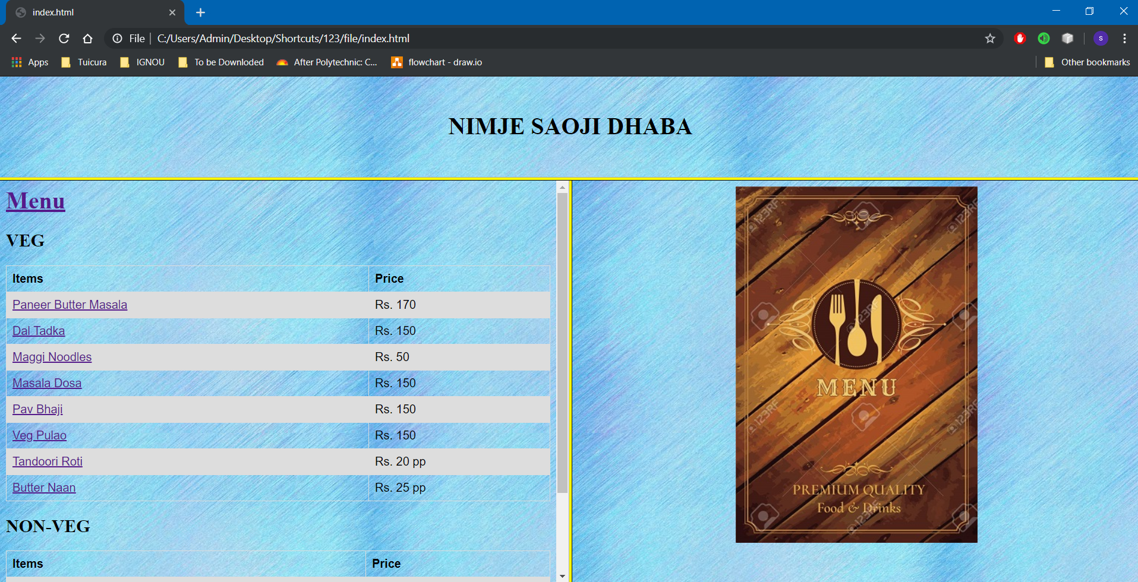

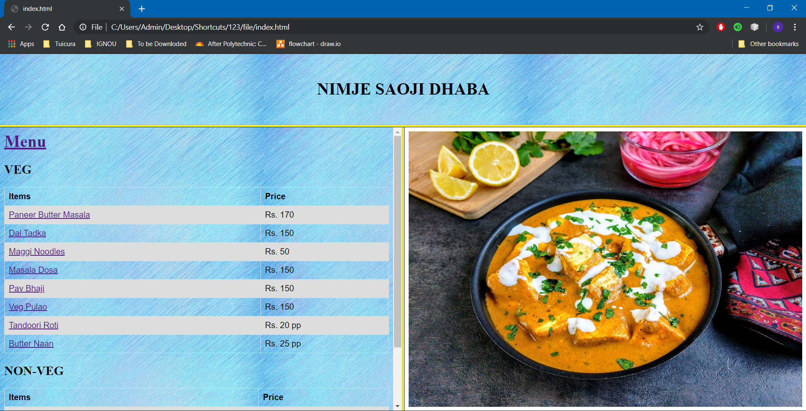

**References:**

[https://www.geeksforgeeks.org](https://www.geeksforgeeks.org/java-how-to-start-learning-java/)

[https://www.studytonight.com](https://www.studytonight.com/java/)

[https://www.tutorialspoint.com](https://www.tutorialspoint.com/java/index.htm)